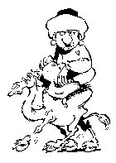
I’m The sheik of Araby
Your love belongs to me
At night when your’re a sleep
Into your tent I’ll creep
The stars that shine above,
Will light our way to love.
You’ll rule this land with me;
The sheik of Araby.
The Scheik of Araby
HELLO, DOLLY
Hello, Dolly, well, hello Dolly.
It’s so nice to have you back where you belong.
You’re looking swell, Dolly, we can tell, Dolly,
you’re still glowin’, you’re still crowin’, you’re still goin’ srong.
We feel the room swayin’, for the band’s playin’
one of your old fav’rite songs from way back when.
So take her wrap, fellas, find her an empty lap, fellas,
(So golly gee, fellas, find her a vacant knee, fellas,)
Dolly ‘ll never go away again!
Helgo away, Dolly ‘ll never go away,
Dolly ‘ll never go away again!
